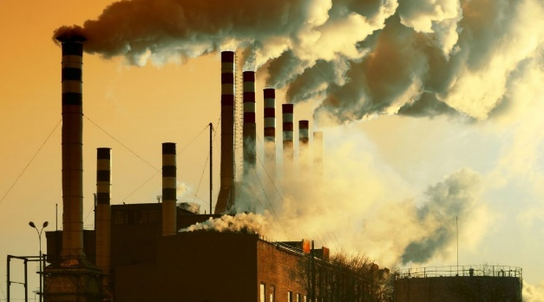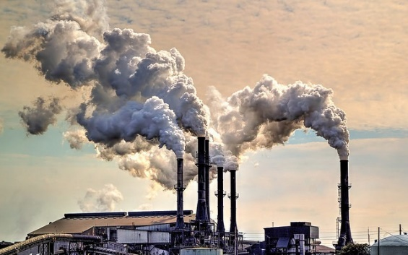

**Case Study: Environmental Pollution Control**

A city government is developing a strategy to minimize **pollution reduction costs** while ensuring air quality standards are met. They have three sources of pollution: **Factory A**, **Factory B**, and **Factory C**, and they must reduce emissions from these factories to meet air quality regulations.

**Details:**

1. **Pollution Reduction Costs**:
   * Factory A: $20/ton of reduction.
   * Factory B: $15/ton of reduction.
   * Factory C: $25/ton of reduction.
2. **Pollution Produced**:
   * Factory A: 50 tons/day.
   * Factory B: 60 tons/day.
   * Factory C: 40 tons/day.
3. **Regulatory Requirements**:
   * Total pollution reduction across all factories must be at least **80 tons/day**.
   * Pollution reduction from Factory B must be at least **30 tons/day**.
   * Pollution reduction from Factory C must be at least **20 tons/day**.
4. **Max Reduction Limit**:
   * Each factory can only reduce pollution by up to 80% of its current pollution level:
     + Factory A: Max reduction = 0.8×50=40 tons/day.
     + Factory B: Max reduction = 0.8×60=48 tons/day.
     + Factory C: Max reduction = 0.8×40=32 tons/day.

**Task for Students**

1. **Formulate the Problem**:
   * Translate the pollution control scenario into an LP model.
   * Write the primal problem with its objective function and constraints.
2. **Solve Using Python**:
   * Use the two Python codes provided to solve the problem using:
     + **Simplex Method**
     + **Interior Point Method**
   * Compare the results:
     + Are the optimal pollution reduction plans (values of xA, xB, xC​) the same?
     + Is the minimum cost (C) the same?
3. **Analyze the Results**:
   * Reflect on how the constraints (e.g., regulatory requirements and factory limits) influence the optimal solution.
   * Discuss any differences between the Simplex and Interior Point solutions, if they exist.

**Objective:**

Minimize:

C=20xA+15xB+25xC

Where xA​, xB​, and xC​ represent the amount of pollution reduction (in tons/day) at Factories A, B, and C, respectively.

**Constraints:**

1. Total Pollution Reduction: xA+xB+xC≥80
2. Factory B Reduction: xB≥30
3. Factory C Reduction: xC≥20
4. Maximum Reduction Limits: xA≤40, xB≤48, xC≤32
5. Non-Negativity: xA,xB,xC≥0